Betula ermanii

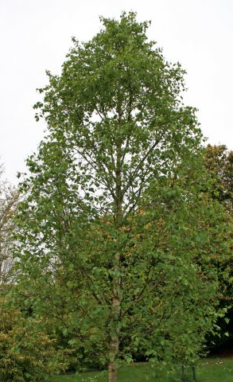
A graceful, medium to large, vigorous broadly conical tree with rough shoots and striking white bark. The bark is conspicuously marked with horizontal grey-brown bands that are creamy coloured when freshly exposed. Glossy green, finely toothed leaves, up to 7.5cm long turn yellow in autumn. Male catkins open in the spring.
Soil: Thrives in any well drained soil.
Aspect: Full sun or part shade.
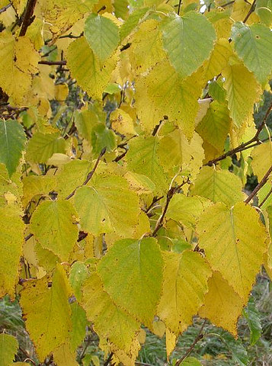
Suitable Locations: Cottage or low maintenance gardens.

